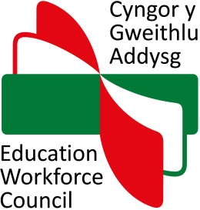

Notification of major changes to an accredited programme of ITE

How to complete this form

- This form is to be completed as appropriate on every occasion of a major change(s) to an accredited programme of ITE.

- Complete all sections of the form. Do not attach any additional evidence or information at this stage.

- Once you have completed this form, please email it to EWC at iteaccreditation@ewc.wales.

Further details about submitting major changes to an accredited programme can be found in the EWC’s guidance ‘Submitting a programme of initial teacher education to EWC for accreditation’.

Section 1: Partnership details

Partnership name:

Programme title:

Submitted by (partnership lead contact):
(Name, position, address, email and telephone details)

Electronic signature:

Date:

Section 2: Intended change(s) and potential impact

Description of change(s):
Please provide as detailed a description of the change(s) as possible.

Date from which change(s) will be implemented:

Impact of change(s):
In order to assess how the intended change(s) will impact on how the programme continues to meet the criteria for the accreditation of Initial Teacher Education programmes in Wales (the criteria), it is useful if changes are put in the context of the Criteria.

Mae’r ddogfen yma hefyd ar gael yn Gymraeg.
This document is also available in Welsh.

