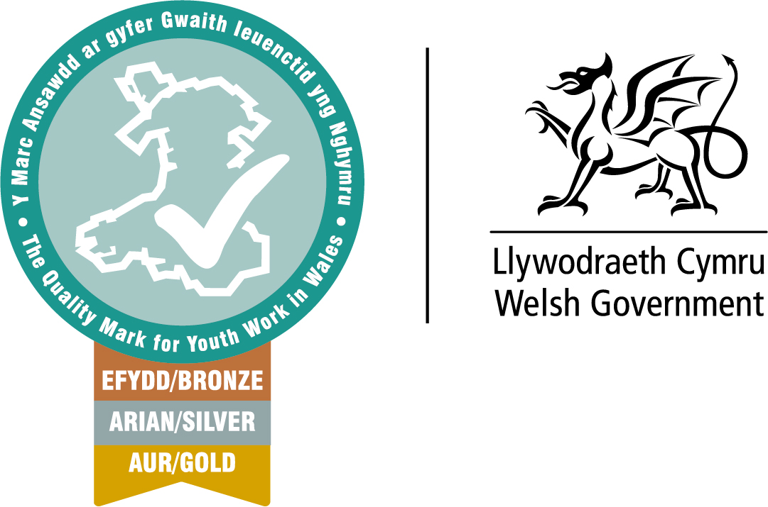  Youth Work Quality Mark for Wales  Self-assessment guidance and advice. | Abstract  Tips and hints on how to develop your organisations self-assessment process and tools you can use to include your team.  Andrew Borsden  Youth Work Quality Mark Development officer EWC

March 2024
Contents
Introduction…………………………………………………………………………….. 3
Preparing a Self-Assessment…………………………………………………….. 5
Pitfalls to avoid…………………………………………………………………………. 9
Getting started………………………………………………………………………….. 7
Commitment…………………………………………………………………………….. 11
Communication…………………………………………………………………………. 12
Evidence……………………………………………………………………………………. 12
Conclusion…………………………………………………………………………………. 13
Appendix A Self-Assessment preparation ………………………………….. 14
Appendix B Self-Assessment process …………………………………………..16
Appendix C Strengths and Weaknesses task …………………………………19

Introduction
Self-assessment underpins many quality and performance improvement initiatives and can be used by Youth Service and Youth organisations leadership teams to improve understanding of their organisations and to identify opportunities for continuous improvement. Continuous improvement is central to the principles of the Youth Work Quality Mark for Wales.
More detail on the Quality Mark can be found on the EWC website here
The self-assessment process provides organisations with an opportunity to review the way they work and identify evidence of what they do well and where they could improve. It is important for organisations to understand the scale of this task and to allocate sufficient resources to complete the self-assessment and prepare the portfolio of evidence. Trustees and/or senior officers should be aware of the resource needed and should commit to providing strategic support.
It is recommended that a nominated individual takes overall responsibility for leading the collation of evidence for the portfolio, completing the self-assessment template and for applying for The Quality Mark. But we recognise that a whole youth service or provision provider will wish to include its whole team in the assessment as practically as possible and we therefore advocate group self-assessment processes to advocate ownership of the process.
Larger organisations might find it useful to set up a working group of people who can co-ordinate specific areas. Templates for self-assessment are provided for each Level (Bronze, Silver, and Gold).
Good practice tip: When completing the self-assessment templates organisations must:
- Describe and evidence how each indicator has been met.
- Submit succinct evidence that clearly demonstrates how it links to the indicator.
- Include details of any learning and plans for improvement identified during the self-assessment process.
Self-assessment is a key tool in the drive for continuous improvement. Continuous improvement is the challenge facing all youth work and youth support service providers in both voluntary and statutory sectors. Pressure on resources, increased expectations from funders and service users, technological advances and the increasing availability of comparative information mean that organisations are required to deliver more and better services to meet young people’s needs and maintain service quality and meet targets and goals.
Most organisations have experienced improvement or quality initiatives that have failed. Many such initiatives either falter quickly, or are abandoned, before they have achieved their aims, often to be replaced by some new approach or technique. Consequently, improvement initiatives come to be seen as faddish and it is little wonder that organisations and individuals become weary of them and sceptical about their likely success. If performance improvement is tackled as a series of initiatives that can be started and stopped, or simply allowed to lapse, it can feel like an additional burden, rather than as central to the success of the organisation. Many organisations have now learned that it is better to maintain and support a continuous focus on performance improvement than have to set up new initiatives to meet new challenges. Sporadic or intermittent focus on improvement can mean that organisations fail to identify poor performance or opportunities for improvement until it is too late.
Continuous improvement maintains momentum and drive for performance improvement. The classic quality cycle of Assess, Plan, Act, Check can be embedded into planning programmes to ensure that continuous improvement becomes integral to the organisation's working. Poor performance is seldom the result of an isolated incident or mistake. It is more often the result of inadequate, or outdated, management arrangements or processes. What was good enough last year, may not be effective today.

Continuous improvement requires a shift in culture and approach within organisations. Self-assessment can help deliver this because it creates new opportunities for involvement and ownership. It is also often less threatening for managers to identify and rectify organisational weaknesses themselves than have a third party to do it for them. This can shorten the time between recognising a problem, and or acting on opportunities when presented.
Preparing a Self-Assessment
When preparing for the Youth Work Quality Mark for Wales we recommend that roles are assigned within a staff or voluntary group. That all Youth Workers in an organisation have an awareness of the process and play an active part in the self-assessment process.
There are 5 essential questions about your practice or youth work you need to address in planning for continuous improvement:
- What are we seeking to achieve?
- Why are we doing it?
- How are we doing it?
- Are we achieving our goals? and
- Can we get better?
To demonstrate ‘Best Practice’ the value of your youth work requires youth workers to reflect on their practice or provision and ask themselves these questions regularly and ensure they are acting on the conclusions they have reached.
Self-assessment contributes to continuous improvement by providing a structured opportunity to assess performance and identify improvements.
Good practice tip: Performance improvement starts with the question "How well are we doing?" Self-assessment helps to answer that question, and those that flow from it:
- "How do we know?"
- "How can we do better?"

Self-assessment is also a key part of many appraisals and performance management systems which encourage individual employees to reflect on their past performance and identify how it can improve. Again, reflective practice and the use of’ Kolb and Gibbs models of reflection are common place in Youth Work, self-assessment is not an uncommon practice in the Youth sector.
Self-assessment can also help to create a learning culture by encouraging participants to ask "How well are we doing?" and "How can we improve?"
Other benefits realised by organisations using self-assessment include: Securing greater focus on, and commitment to, continuous improvement among Youth Service managers, youth workers and leaders, and volunteers. Some benefits of a unified collaborative approach
- better performance measurement;
- better action planning;
- improved operational and financial performance;
- improved benefits and impact with young people;
- shared understanding among management teams;
- Personal growth and development of those involved in the process;
- Improved manager and leader CPD and leadership styles.
Self-assessment uses the knowledge that already exists within the organisation. It does not require specialist knowledge to be brought in. Consequently, the skills and knowledge that are acquired during self-assessment stay with the organisation after the assessment process is complete.
Bringing together your youth work team staff with knowledge of the organisation means that the assessment process can begin and progress quickly. There is no steep learning curve about the organisation - although participants in self-assessment will usually learn things about their organisation that they did not already know. Group discussion and consensus building encourages ownership of the strengths and weaknesses of the organisation and of any improvement plans generated to address weaknesses.
It is essential that the people who complete the assessment also agree and can implement the action plan. In some councils, the management arrangements action plans were put to management teams for approval separately from the assessment from which they came. This wasted time and effort as one group of people tried to work out why another group of people, or person, had chosen to address a particular set of issues.
We recommend that managers and leaders of Youth provision take a group self-assessment approach to complete the YWQM templates.
This approach has the following benefits:
- Group self-assessment enables consensus to be reached about current performance and areas for improvement
- Those responsible for delivering improvements are involved in assessing what those improvements should be
- Open discussion reduces the risk of subjectivity and bias
- Managers or leaders will gain a wider understanding of the provision or service.
Group self-assessment will only be as good as the group involved. The group needs to have detailed knowledge of the service or provision being assessed. It may be that additional members are brought into the self-assessment team for the assessment, or that the task is delegated to a small group drawn from the service or provision team. In either case, it is worth spending time ensuring that the group undertaking the assessment has the necessary breadth of knowledge and understanding of all parts of the authority being assessed.
There is usually a compromise to be made between ensuring that a group is large enough to have the breadth of experience, skills and knowledge to undertake an assessment, and ensuring that it remains small enough so that individual members can contribute effectively. The larger the group, the more important the role of the chair or facilitator in ensuring that all members of the group become involved and can participate. It is also key to assign roles e.g. scribe, evidence collator, communications lead.
It is useful to form initial discussions around a SWOT analysis.
A SWOT analysis is a planning tool used to understand key factors - strengths, weaknesses, opportunities, and threats - involved in a project or in an organisation. It involves stating the objective of the organisation or project and identifying the internal and external factors that are either supportive or unfavourable to achieving that objective. SWOT is often used as part of a strategic or planning process, but can be applied to help understand an organisation or a situation, and also for decision-making for many different scenarios.
The value of SWOT lies mainly in the fact that it offers self-assessment for management. The methodology has the advantage of being used as both a 'quick and dirty' tool or a comprehensive management tool, and that one (the quick) can lead to the other (the comprehensive). This flexibility is one of the factors that has contributed to its success.
There are a number of advantages and disadvantages of using the SWOT approach to analysis.
Advantages include:
- It's a simple four box framework.
- It facilitates an understanding of the strengths and weaknesses of the organisation.
- It encourages the development of strategic thinking.
- It enables senior managers to focus on strengths and build opportunities.
- It can enable an organisation to anticipate future business threats and take action to avoid or minimise their impact.
- It can enable an organisation to spot business opportunities and exploit them fully.
- It's flexible.
Disadvantages include:
- Some SWOT analysis users oversimplify the amount of data used for decisions – it’s easy to use insufficient data.
- The risk of capturing too much data may lead to ‘paralysis by analyses.
- The data used may be based on assumptions that later prove to be unfounded.
- Access to quality internal data sources can be time consuming and politically difficult (especially in more complex organisations – parent company, etc.).
- It lacks detailed structure, so key elements may get missed.
- The pace of change makes it increasingly difficult to anticipate developments that may affect an organisation in the future.
- To be effective, the process needs to be repeated on a regular basis.

However, while the elements can appear deceptively simple and easy to apply, experience shows that to do a SWOT analysis that’s both effective and meaningful, requires time and a significant resource. Deciding what the strengths and weaknesses of an organisation are, as well as assessing the impact and probability of opportunities and threats, is far more complex than first appears. It requires a team effort and can’t be done effectively by just one person.
Pitfalls to avoid
Self-assessment is widely used because it delivers results. Creating the right conditions for successful self-assessment can save time and increase the rewards from the process. Common pitfalls include;
- Failing to ensure that participants understand the process that will be used, the purpose of the exercise and their own role in it.
- Lack of preparation for self-assessment sessions can mean that time is wasted trying to find evidence to shore up, or discredit, subjective opinions expressed during the assessment session
- Assessment sessions are different from most of the meetings that youth work teams will have and require an atmosphere which enables participants to share and test out opinions, listen to the views of others and be prepared to adjust and alter opinions in the light of discussion.

Getting started
To do self-assessment effectively and to reduce stress the importance of the following factors in securing positive results from self-assessment must be considered:
- commitment
- communication
- preparation
- evidence

Commitment
As with any improvement activity, commitment is required from the leadership team. Without that commitment the exercise will fail to be seen as important and it is unlikely that the necessary inputs to the process will be secured. Commitment is required:
- to the assessment process
- to enable participants to contribute
- to use the process as a learning opportunity
- to use the results of the assessment and implementing improvements
- to integrate the self-assessment into existing planning and review frameworks.
Creating the right climate for successful self-assessment means ensuring that the exercise is given sufficient status. The involvement of key people is important. Having identified who will take part, commitment to the process can be demonstrated by ensuring that participants are given the time to prepare for, and complete, the assessment. Commitment can also be demonstrated by ensuring that the results of the assessment are shared within the group and by highlighting and supporting agreed actions resulting from it.
Communication.
Effective communication is important. The way in which people first hear about the assessment will have an important influence on how they approach it. Setting out clearly to participants what the purpose of the exercise is, who is involved and what is expected of them will save time and avoid confusion.
It is equally important to ensure good communication with those who are not directly involved in the administration of assessment, particularly young people. This can help to avoid suspicion about the process and the actions that will flow from it. Communicating quickly and clearly the results of the assessment and the actions that will be taken will help to demonstrate commitment to the exercise.
Good practice tip: young people’s views and opinions of the youth service or provision provided to them are to be considered and the roles they play in the life or daily running of organisations are key factors to be considered when preparing your self-assessment.
Good practice tip: Develop a communication checklist e.g.
Have you set out clearly for participants?
- what the assessment is for;
- who is involved and why;
- what is expected of them (preparation, participation, approach);
- Timescales? Deadlines for stages of the assessment being set.
How widely you will report on the assessment?
Who needs to know?
Will you explain?
- what the assessment was for;
- who was involved and why;
- what the assessment found;
- What action will be taken?
How will you report back on the implementation of actions?
Evidence
A self-assessment is only as good as the information on which it was based. Effective management of self-assessment means minimising the opportunities for bias by emphasising the need for participants to evidence their views about performance. Time spent collecting evidence will be rewarded with soundly based judgements.
Performance information is essential. The first task is to establish current levels of performance. Establishing trends over time is important. Survey information and performance reports to senior leaders, trustees or steering groups, will be useful. Collecting this evidence will be a test of the organisation’s information system. Evidence examples are included in the Youth Work Quality Mark Guidance and are not exhaustive.
However, evidence needs to be valid, robust and clear. It is strongly suggested that evidence which is older than 2 years is not to be included in your self-assessment. When including evidence of young people’s work or involvement in your service or provision please adhere to issues relating to safeguarding and their personal confidentiality and wellbeing. It is important when collating a collection of evidence portfolios that they are matched and linked to Youth Work Quality Mark standards and indicators.
On occasion evidence will lend itself to more than one standard. Please ensure that any narrative reports on such uses of evidence.
Tip: Evidence must be relevant, owned by the organisation, reliable and linked clearly to Quality Mark indicators and standards.
Conclusion
Self-assessment is a valuable tool in improving performance. Group self-assessment brings maximum benefits by ensuring that assessments are informed by a variety of views about performance and by encouraging consensus to be reached about current performance and improvements which should be prioritised.
Key factors which ensure the success of self-assessment are:
- Commitment from the senior management team
- Communication about the assessment, how it will be used and who will be involved
- Preparation is key to success use this time wisely
- Evidence ensuring that assessments are based on evidence and not opinion
Assessment is best approached constructively and as an opportunity to learn about the organisation. Once current performance has been assessed, ideas for improvement should be developed. Self-assessment will contribute to performance improvement when it is integrated into planning and review processes, rather than conducted in isolation from them.

Appendix A
Before starting a self-assessment, you will need to make many decisions. You will need to ask some questions: Why are we doing this? How will we do it? Who will do it?
• Reasons for undertaking a self-assessment;
• Your organization's readiness for self-assessment;
• The users of the results and the interests of different stakeholders in the process;
• The scope of the intervention and required resources; and
• The self-assessment team.

Why would you conduct a self-assessment?

It is important to clarify your reasons for undertaking the self-assessment. Once you are clear about this, you will find it easier to determine
• The scope of the intervention;
• The depth of data required;
• Its focus in terms of issues (such as performance, capacity, organizational motivation, environment); and
• The cost. This can be equated to capacity or maybe bringing in a third party as an advisor or author

Some typical reasons for conducting a self-assessment

It is common for an organization to conduct a self-assessment when it is at a turning point in its history. An organization may also find a self-assessment useful when it needs to make decisions about particular aspects of the organization itself:
• Strategic decisions - Should the organization grow? Merge? Shrink? Change
its mission?
• Program decisions - Should programs be expanded? Should two or several
Projects or activities be integrated? Should new services be offered?
• Financial-feasibility decisions - Should new investors be sought? Should funding sources be more diversified and how? Should new approaches to fundraising be identified?
• Staffing decisions - Should staff with different skills be hired to support the mission? Should the organization let some staff go, and if so, who?

Other reasons might be less specific; for example, the self-assessment might have the following objectives:
• To identify the organisation's strengths and weaknesses - a first step toward improvement;
• To identify issues and problems before correction becomes difficult
or impossible;
• To identify the needs that should be addressed through specific action;
• To identify human and other resources the organisation can use
to effectively improve its performance;
• To document the desired outcomes of the organization's activities;
• To generate information useful in planning and decision-making;
• To assist in fundraising; and
• To provide donors and other stakeholders with information about the organisation's performance.
DEALING WITH FUNDING CUTS
Self-Assessment can also be used to support an organisation facing funding reductions. The organisation will need to decide whether it should close down, cut down on staff and programs, or commission out pieces of work or projects. Each option had major implications for the agency's programs and services, staffing requirements, and funding mechanisms. To gain an understanding of these implications, the service could undertake a self-assessment. With this knowledge, the organization may able to make an informed decisions.

Appendix B
Tips for the self-assessment process
The following are a quick guide reminder to help organisations to complete their self-assessment:
- Organisations should use the self-assessment process as an opportunity to highlight and celebrate what they do well. This is an opportunity for the organisation to celebrate and provide evidence of the quality of their work with young people.

- The narrative for each indicator should be used to describe the organisation’s policies, processes and practice. It is important to ‘tell the story’ about how the organisation meets each indicator and provide evidence that demonstrates the ‘good practice’ grade.

- It is helpful to think clearly and systematically about what should be the first piece of evidence in each indicator. This will probably be a policy, strategy or guidelines that describe the context and arrangements for implementation.

- It is important to provide evidence from a range of projects so that the self-assessment provides a full picture of the organisation’s work with young people. Where an organisation is involved in the delivering a wide range of youth work, there is an expectation that evidence will be provided from open access provision and targeted youth work.

- Any evidence referenced in the narrative should be underlined and provided in either an electronic file or hard copy. For example, an organisation’s annual plan would be useful evidence for the standard on ‘Performance Management’. Part of the narrative might say, “The Annual Plan with performance targets demonstrates one way in which we measure impact and effectiveness. The Quarterly Reports provide evidence of a systematic process for monitoring and reviewing performance.” In this case, the Annual Plan and Quarterly Reports should be provided as supporting evidence.

- It is important to provide evidence of how performance is monitored and reviewed. Most organisations have processes for monitoring and reviewing their performance and should be able to provide evidence of how these processes are implemented; for example, minutes of team meetings where performance is reviewed, regular performance reports, notes from supervision meetings where performance is discussed.

- In order for the self-assessment to be more than a “snapshot” taken at a particular point in time, the narrative and supporting evidence should identify any on-going or planned improvements that arise out of routine monitoring, evaluation or undertaking the self-assessment process for the Quality Mark.

- It is important to identify evidence that demonstrates impact. This evidence might be provided in a variety of ways; for example, numerical data; case studies; young people’s evaluation of their learning; and evidence of how engaging in youth work has improved young people’s outcomes and/or life chances.

- Avoid presenting raw data; the self-assessment should provide evidence of how data has been analysed, what this analysis indicates and how it is used to inform plans for improvement. For example, when providing evidence for the standard on Recognising and celebrating young people’s achievement and progress, an organisation might submit data on the number of young people that take up opportunities to have their learning accredited. The commentary should identify trends in this data; this might be an increase or decrease in the number of young people involved in accredited learning. It should also identify the reasons for this change. It might be that numbers are rising because staff are promoting these opportunities more effectively or because young people find qualifications useful in applying for education, training or employment.

- When using documents as evidence, it is useful to reference specific sections or pages within the narrative. If an electronic portfolio is submitted, where possible hyperlinks to the evidence should be included. This makes the task of reviewing the evidence much easier for an assessor from the Awarding Body.

- It is very important to include direct evidence from young people; for example, evidence of their engagement in planning and evaluation, their views on what they’ve learnt, their feedback or case studies. Often this is the evidence youth workers gather on flipcharts, in photographic displays or on feedback sheets. It can be provided either in; electronic form, hard copy and through focus groups during the assessment visit. Remember, young people often provide the best evidence.

- Ensure that when an acronym is used the full name or term is provided on its first use or include a glossary.

- Provide full contact details for the person within the organisation leading on The Quality Mark.

- It is important to remember that a small number of well-chosen documents demonstrating that the organisation has achieved a ‘good practice’ grade will be more helpful than piles of information that partly address the evidence requirements.

- Remember that assessment is less about the volume of evidence and more about good evidence which clearly demonstrates a ‘good practice’ grade for each indicator

Appendix C
Instructions. Follow the guidance below and create a list of your organisations top 5 strengths and weaknesses.
Part 1 (10 minutes)
• On your own, read the following list of elements that many organisations perceive as their strengths or weaknesses (see "Key-areas list," below). This is not a complete list and you may identify other strengths or weaknesses.
• As you read the list, ask yourself "Is my organisation particularly strong or weak in this
area?"
• Write down your organisations five major strengths and five major weaknesses.
Part 2 (30 minutes)
• Form a group with four other people.
• Share your lists and develop one common list of five strengths and five weaknesses.
• Write your final list on a flip chart.
Part 3 (the whole group)
• Review the team lists.
• Vote on the top five key areas.
Key-areas list
• Leadership (management culture, setting directions, supporting resource development, ensuring tasks are done)
• Identity (knowing who we are and what we are good at)
• Mission
• Organizational culture (attitudes about work, values, beliefs, underlying norms)
• Incentive and reward systems
• Governance (legal framework, decision-making process, representation on the Board of Directors, key partnerships and or regional frame works methods for setting directions)

Who is my organisation what are the strengths and weaknesses of our internal environment?
How do the following influence our work? Make a list of positive and negative impacts
- Organizational structure (roles and responsibilities, coordinating systems, authority structures)
- Niche recognition (understanding of uniqueness, areas of expertise)
- Staff Management of infrastructure (equipment, maintenance systems, choice of location)
- Financial systems (planning, managing, and monitoring cash flow) Fundraising capacities
- Communicating about the organization with our stakeholders Partnerships (types, numbers, cost-benefits, etc.)
- Networks (types, nature, utility, coordination, follow-up processes) Human-resource policy
- Career management
- Equity
- Compensation and reward
- Dedication and loyalty of our staff
- Expertise and quality of our staff
- Planning mechanisms (identifying needs, looking at alternatives, setting objectives, etc.)
- Problem-solving and decision-making (defining problems, gathering data, creating alternatives, monitoring decisions)
- Monitoring and evaluation (generating data, tracking progress, making judgments about performance)
- Skills and expertise in projects undertaken
- Building sustainable projects for community and Aboriginal groups Providing good value for money
- Relationships with beneficiaries
What are my organisation and our collective organisations top 5 major strengths and weaknesses?
List strengths.
1.
2.
3.
4.
5.
List weaknesses.
1.
2.
3.
4.
5



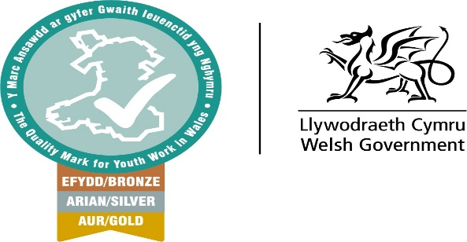

Youth Work Quality Mark
Self-assessment guidance and advice.

