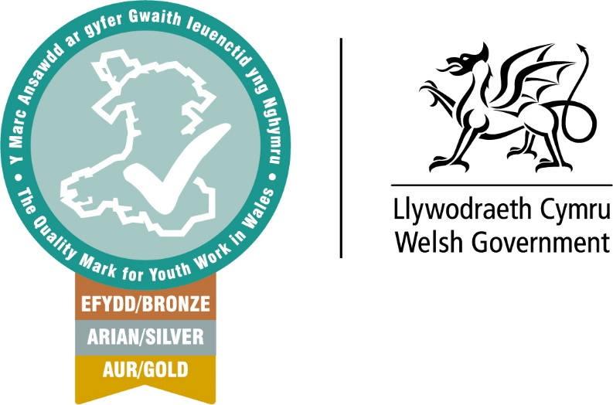

Advice on setting up a Google Drive for Youth Work Quality Mark Assessment.
The following is general advice and suggested guidance for accessing a storage system for your Youth Work Quality Mark Assessment. We will give examples of how to establish folders and to make evidence accessible to Assessors. Most youth sector groups can access Google Drive at no cost.
Creating a Google account is free, and gives you access to Google Drive, as well as other Google Services, such as Gmail, Google Calendar, and Google Photos. Once you've signed up for an account (or signed into an existing account), you can access Google Drive in your browser by going to www.drive.google.com.
Google Accounts don't have to use a gmail.com address. You can associate any existing email address with a Google Account. Alternatively, files can be shared with non-Google accounts using visitor sharing.

Share files from Google Drive. You can share the files and folders that you store in Google Drive with anyone. When you share from Google Drive, you can control whether people can edit, comment on, or only view the file. This will give you added security and overall control over who has access to your information and data.
Getting started with Google Drive.
The following YouTube tutorial video will give guidance on establishing your Google Drive. https://edu.gcfglobal.org/en/googledriveanddocs/getting-started-with-google-drive/1/ It will give instructions on how to link files and create folders and how to integrate the Google drive to your desktop and hand held devises.
If you need to create files, folders and or general documents for your Youth Work Quality Mark Assessment the following video can give you advice on how to do so using Google docs. https://edu.gcfglobal.org/en/googledriveanddocs/creating-google-docs/1/

Once you have established your Google Drive you can begin to populate files with evidence and to use the Google drive as the main work space for the editing of your Youth Work Quality Mark Self-Assessment Report. We encourage our applicants to use hyperlinks in their self-assessment documents which link to evidence and files in the Google Drive. If you’re not sure on how to insert hyperlinks into your Word Documents please see the following video. https://www.youtube.com/watch?v=J63yPl4BGH4 OR https://www.bing.com/videos/riverview/relatedvideo?&q=USING+HYERLINKS&qpvt=USING+HYERLINKS&mid=99380BAF38D1938F936999380BAF38D1938F9369&&FORM=VRDGAR
Example of Hyperlink (blue and underlined)
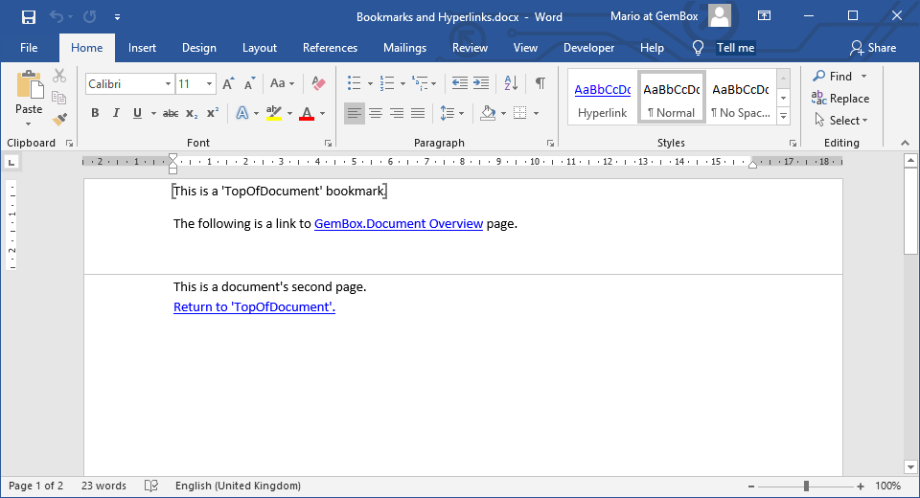

We would like organisation to ensure their Self-Assessment report is linked in their Google Drive to evidence folders and other documents like the example below.
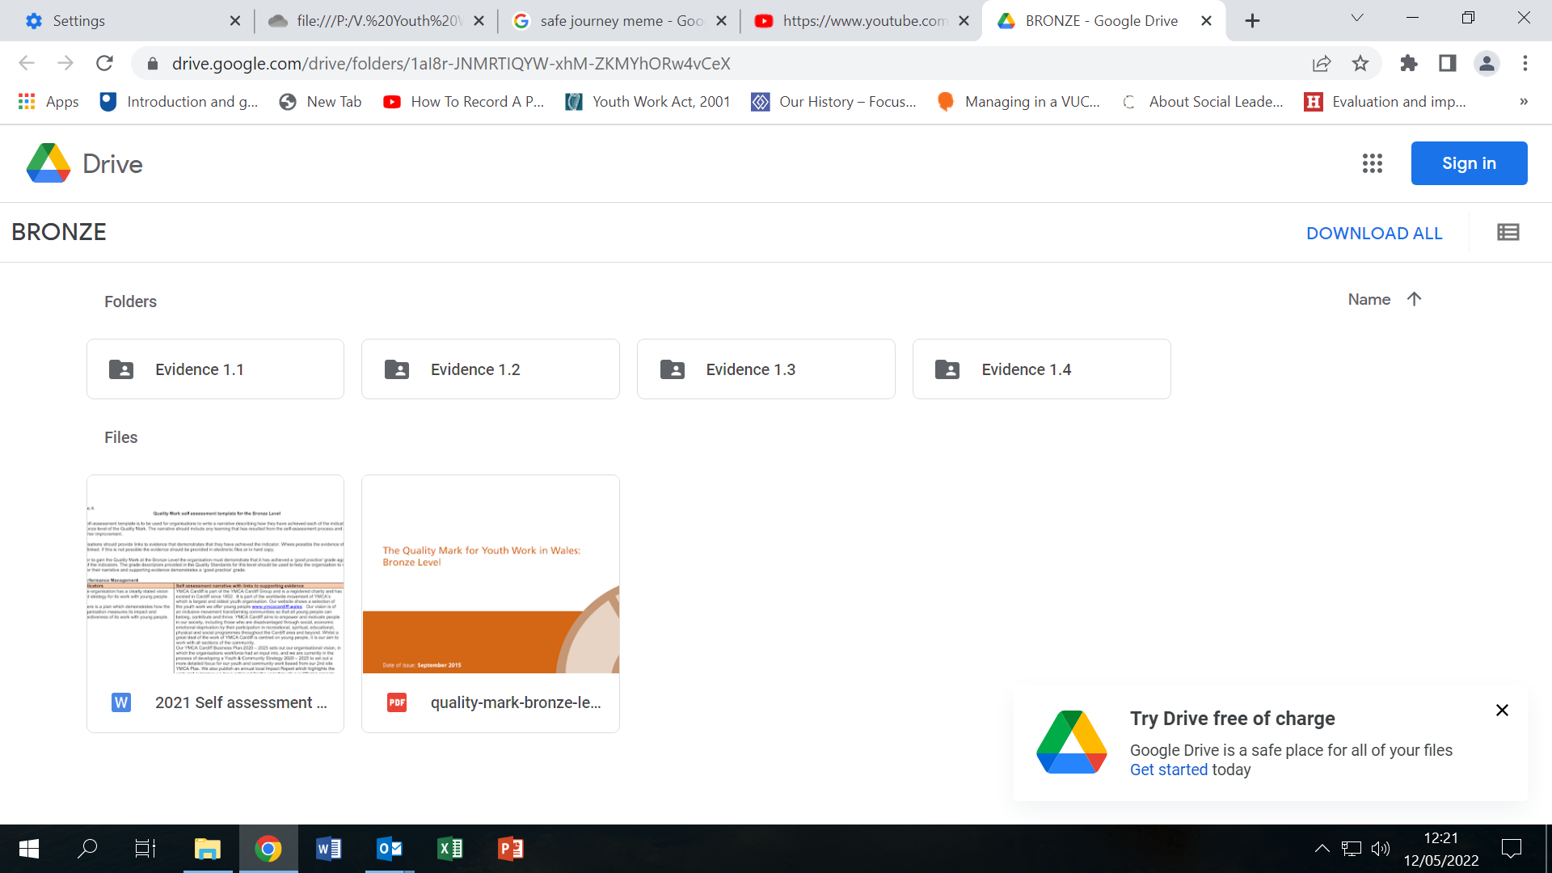
When clicking on the folder Evidence 1.1 this should open up to reveal the evidence contained in the file. Like the example below.
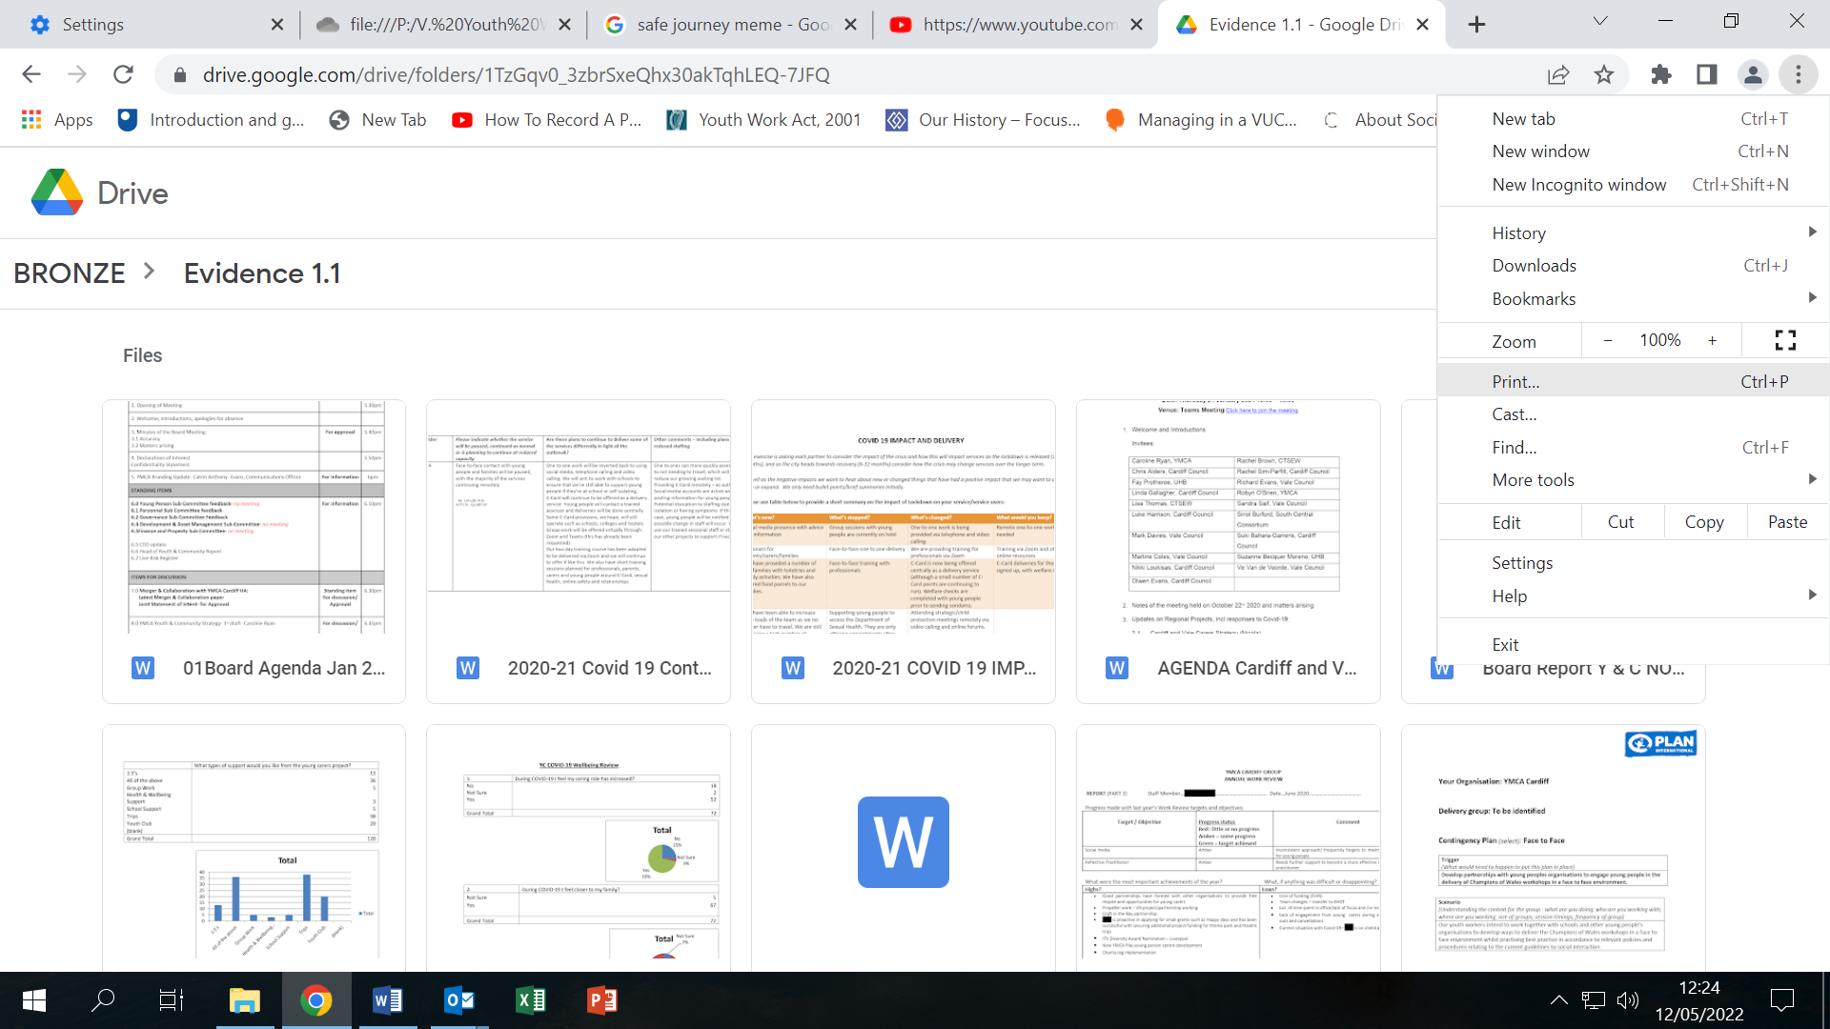

The evidence in the example above would be accessed via hyperlink in the self-assessment document.
If you are unsure of how to use a hyperlink, after watching the video referenced earlier follow the instructions below.
To link to another document in Microsoft Word, follow these steps:
- Insert a Link:
  - Select the text or object you want to use as a hyperlink.
  - Press Ctrl+K or right-click and choose Hyperlink.
  - Click to select “Existing File or Web Page” from the list of “Link To” options.
  - Locate the document you want to link to, then click OK.
  - Word will successfully insert a link in your document that points to another document on your computer or network this text will link you to further advice.
Further advice on developing your Youth Work Quality Mark evidence storage can be sought from the Youth Work Quality Mark Development Officer.
Other operating systems are similar to the above.
You can also set up files in
MS365 https://support.microsoft.com/en-us/office/organize-your-files-in-onedrive-3eed202a-dee1-41fb-a719-baca4dda8e32 you can share files with anyone using the guidance here
Dropbox https://help.dropbox.com/files-folders/share/add-files
Teams https://www.youtube.com/watch?v=cYbmiXzlzwE

